**AIM:**

Write a C program to perform Matrix Multiplication

**ALGORITHM**

1. **Start**
2. Read the number of rows m1 and columns n1 of the first matrix **A**.
3. Read the number of rows m2 and columns n2 of the second matrix **B**.
4. If n1 != m2, then print “Matrix multiplication not possible” and **Stop**.
5. Read elements of matrix **A**
6. Read elements of matrix **B**.
7. Initialize each element of result matrix **C[i][j] = 0**, for i = 1 to m1 and j = 1 to n2.
8. For i = 1 to m1  
     For j = 1 to n2  
       For k = 1 to n1  
         C[i][j] = C[i][j] + (A[i][k] * B[k][j])
9. Display the result matrix **C**.
10. **Stop**

**CODE**

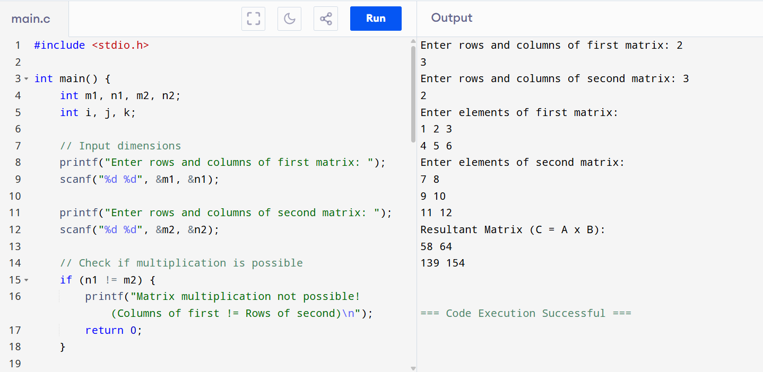

**OUTPUT**

Enter rows and columns of first matrix: 2

3

Enter rows and columns of second matrix: 3

2

Enter elements of first matrix:

1 2 3

4 5 6

Enter elements of second matrix:

7 8

9 10

11 12

Resultant Matrix (C = A x B):

58 64

139 154